Kubernetes Task – 2

eksctl create cluster --name trend-cluster --region ap-south-1 --nodegroup-name trend-nodes --node-type t3.small --nodes 2

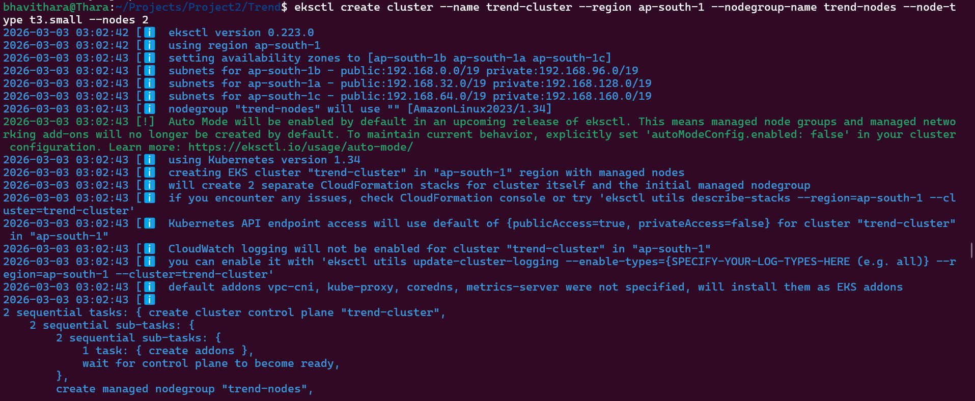

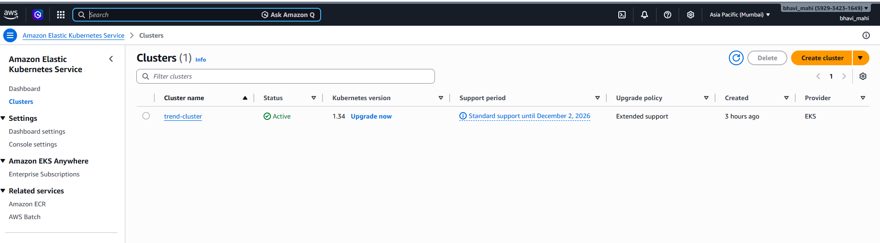
kubectl create deployment nginx-deployment --image=nginx

kubectl expose deployment nginx-deployment \
--type=LoadBalancer \
--port=80

eksctl delete cluster --name nginx-cluster --region ap-south-1

